Software Engineering
Professor: Hoh Peter In

Exam I Sample Questions

NAME: _____________________________ Student ID#: ___________________

- (a) What is SOFTWARE ENGINEERING?
(b) Why is it important?
(c) What are differences between Software Engineering and Computer Science?
(d) Please define “good” software. Which attributes does “bad” software have?

- (a) What is so important for softwere engineers to have “software engineering ethics”?
(b) What are the issues of professional responsibilities?
(c) How do your team apply the ACM/IEEE code of ethics into your class project?
(d) How did you resolve “ethical dilemmas” in your project? Explain with an example.

- (a) What are the software process?
(b) Please compare plan-driven vs. agile processes. Which process did your team adopt in your team project? Why?
(c) What are the problems with the waterfall model? How to overcome these problems?
(d) What are the benefits of incremental development? How to apply incremental development process for your class project?
(e) Please draw the software process model (a set of activities) of your class project. Please discuss pros and cons of your process model. How to overcome the cons of your process model?
(e) What is reuse-oriented software engineering? How to utilize them for your class project? What are their risks? How to mitigate them?
(f) What is V-model? Please suggest the V-model for your class project with detailed milestones (e.g., deadline of each activities; deliverables).
(g) How to make the evolution plan of your class project? What are the top 3 risks of your class project due to evolution? How to mitigate them?

- (a) Is ‘extreme programming’ good or bad for your project? Justify your answer.
(b) What are output of ‘extreme programming (XP)’ (i.e., results produced by XP)?
(c) Please explain “Scrum Sprint Cycle”? How can you apply it for your class project?
(d) What is ‘pair programming’? What are its pros and cons?

- (a) What is a requirement? Why is it so important to have right requirements in early stage of software development?
(b) What are Key challenges of RE? How to overcome them?
(c) What are five key failure factors related to RE among CHAOS projects (See the WinWin slides)
(d) What are functional and non-functional requirements? Why are non-functional requirements hard to elicit? How did you find them in your class project?
(e) What to describe in requirements document? (See SSRD in the MBASE slides)
(f) How to validate requirements? How do you know whether your requirements are correct and whether your requirements are correctly described?
(g) What are types of requirements specification? What are advantages and disadvantages of them?
(f) How to represent requirements consistently, completely, and non-ambiguously? How does the software industry do for this goal?
(e) What are ‘good’ requirements? What are ‘bad’ requirements? Please provide three examples of ‘bad’ requirements specification in the SSRD (requirement document) of your class project. Please correct them into ‘good’ requirements.

- (a) What is MBASE? How can it help your class project?
- Describe the WinWin negotiation results of your class project. What are pros and cons of the WinWin approach? How can you get benefits for your project practically from WinWin?
- Apply MBASE (especially SSRD) for your class project. Find out mismatch of models (or their examples of the mismatches) in MBASE.
- Explain how the MBASE conceptual framework (shown in the following picture) work using your class project
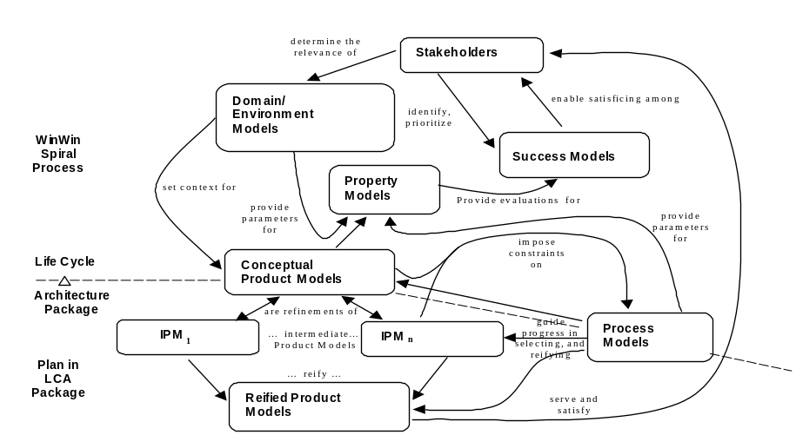

- What are elements of critical font end milestones? What are different between LCO and LCA? Why is Life-cycle plan necessary?
- Please apply “feasibility rationale” for your class project. What can the reader get out of this ‘feasibility rational’ document?

- (a) What is UML? How can it help your class project?
- Explain the following diagram (what it is, why important, how to draw)
  - Use case diagram
  - Sequence diagram
  - Class diagram
  - State diagram

- Draw sequence diagram and class diagram bsed on the following requirements

“A receptionist may transfer data from the Mentcase system to a general patient record database that is maintained by a health authority. The information transferred may either be updated personal information (address, phone number, etc.) or a summary of the patient’s diagnosis and treatment.”

- (a) What is Design Thinking? How can it help your class project?
- Explain the Design Thinking Process with an example (e.g., in your class project)
- What are three tools of How to Empathize? What tool did your project use? What are their results? Good or bad? How to improve it better in next time?
- What is “Empathy Map” (e.g., think, say, feel, do)? Explain it with an exmaple in your class project
- Describe POV (Point-of-View) of your class project.

